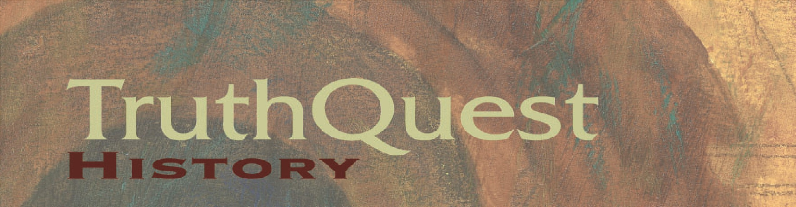
Age of Revolution III
________________

Comprehensive spines, which provide thorough narrative coverage of the entire period:

*Story of the Great Republic, by H.A. Guerber Gr. 3-7
*This Country of Ours and *Island Story, by H.E. Marshall Gr. 3-8
*Basic History of the United States: Volumes 3-6, by Clarence Carson Gr. 9-12

General resources, which either 1) cover world history by making key points about multiple periods or by offering a brief summary of each, or 2) discuss selected events of significance in the period:

*Seven Men Who Rule the World from the Grave, by Dave Breese Gr. 8-12
This book contains some very important insights, and will be cited in the succeeding TruthQuest History guide as well.
*History Through the Eyes of Faith, by Ronald Wells Gr. 9-12
*How Should We Then Live? by Francis Schaeffer [book or video format] Gr. 9-12
One of the most important resources you will ever use! Highly significant and highly recommended!

